**Build & Linting Logs:**

For Services Solution: [0 Errors, 0 Warnings, 0 Messages ]

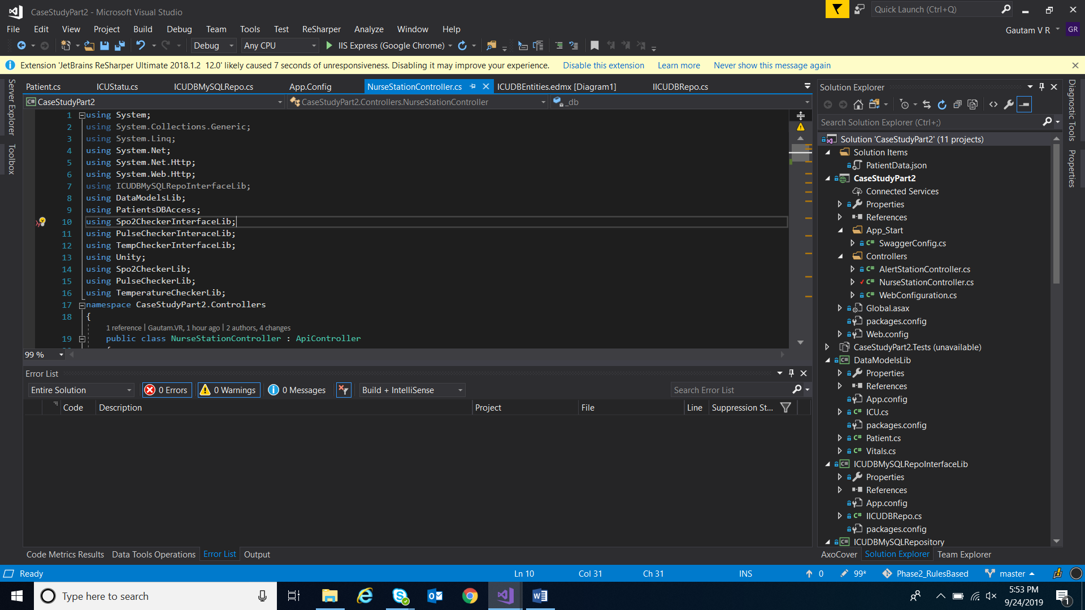

For UI Solution : [0 Errors, 5 Warnings, 0 Messages]

Exception: We have added URLs in client-side to consume the respective services. There warnings stated that absolute path or URLs shouldn’t be hardcoded.

